Experiment 6.2
Convolution of Discrete Time Signals
Aim:
To compute and visualize the convolution of two discrete-time signals. Convolution is a
fundamental operation in discrete-time signal processing that combines two signals to
produce a third signal, which is a modified version of one of the signals.
Program:
% Convolution of Discrete-Time Signals
clc;
clear;
close all;
% Input sequences
x1 = [1 2 3 4];
x2 = [1 1 1];
% Convolution
y = conv(x1,x2);
% Sample indices
n1 = 0:length(x1)-1;
n2 = 0:length(x2)-1;
ny = 0:length(y)-1;
% Display output
disp('Convolution Output:');
disp(y);
% Plotting
figure;
subplot(3,1,1);
stem(n1,x1,'filled');
grid on;
title('Input Sequence x_1(n)');
xlabel('n');
ylabel('Amplitude');
subplot(3,1,2);
stem(n2,x2,'filled');
grid on;
title('Input Sequence x_2(n)');
xlabel('n');
ylabel('Amplitude');
subplot(3,1,3);
stem(ny,y,'filled');
grid on;
title('Convolution Output y(n)');
xlabel('n');
ylabel('Amplitude');
Output Waveform:
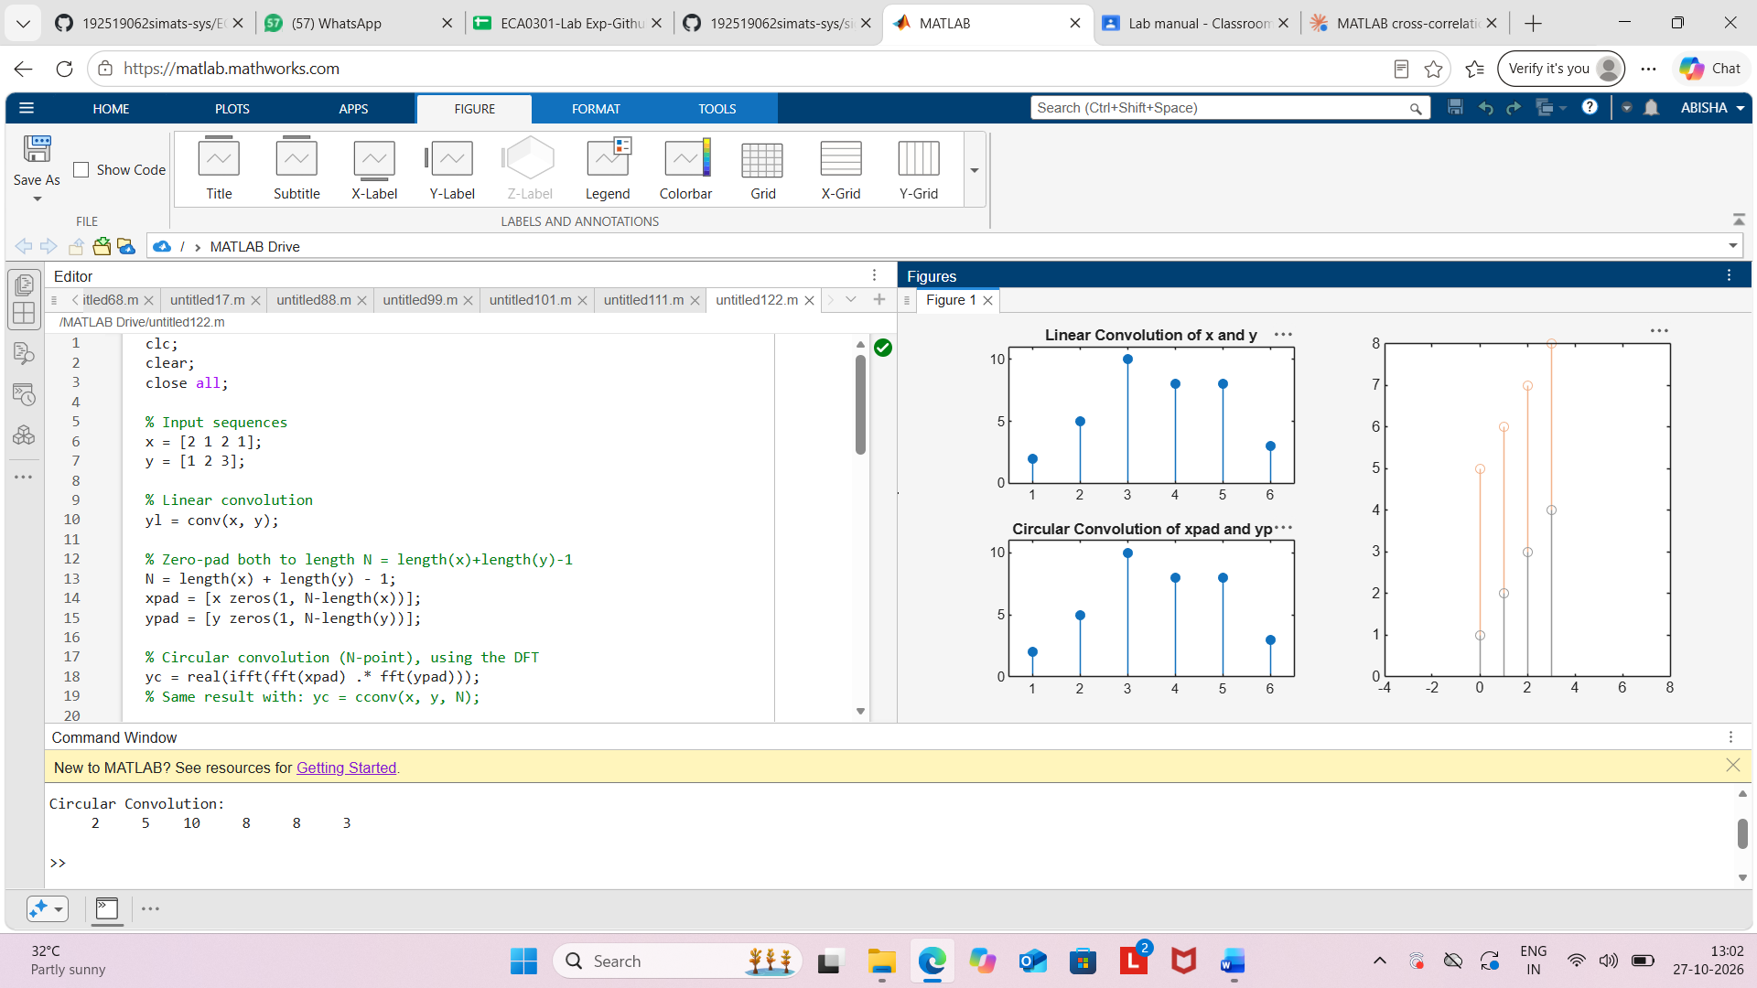
Result:
The convolution of the discrete-time sequences x1(n)={1,2,3,4} and x2(n)={1,1,1} was
performed successfully using MATLAB. The output sequence obtained was
y(n)={1,3,6,9,7,4} demonstrating the convolution operation for discrete-time signals.

